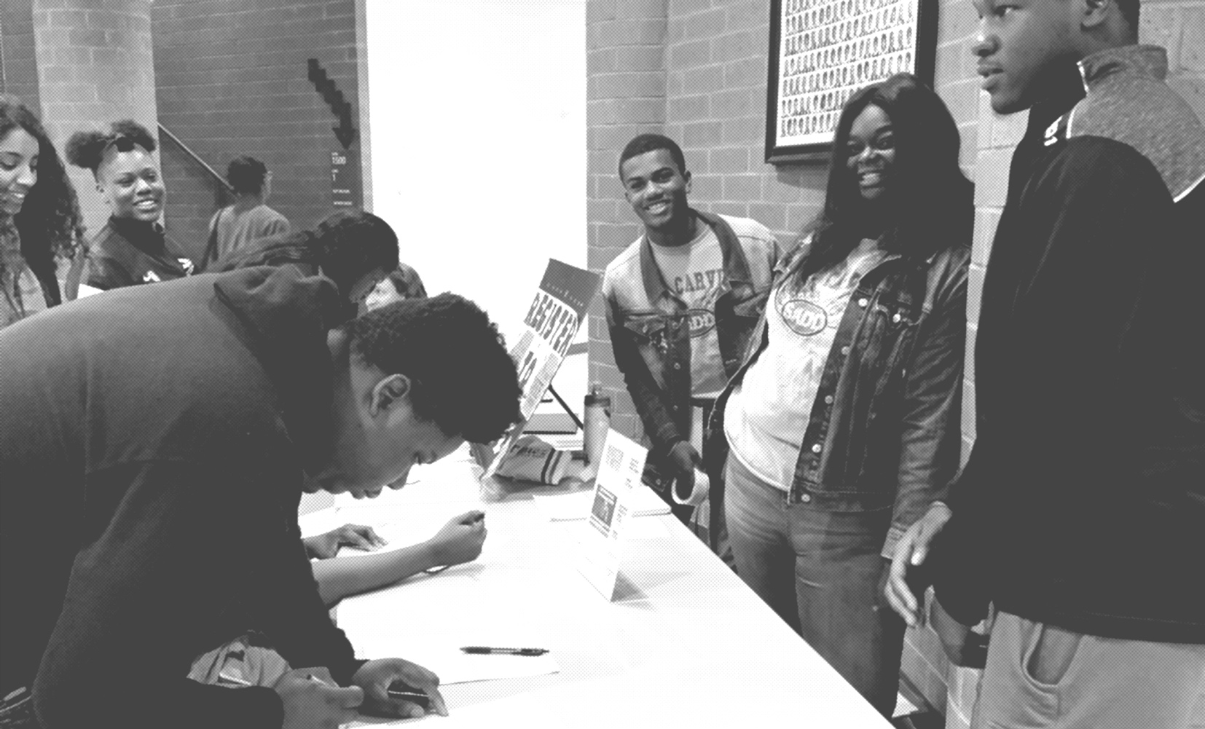

**National Voter Registration Day**

**Tuesday September 20, 2022**

**4.7m**

**voter registrations since 2012**

**800,000**

**NEW registrations goal for 2022**

**This year’s National Voter Registration Day on Tuesday, September 20 marks the 10th anniversary of our annual celebration of democracy and we aim to ring it in by registering AT LEAST 800,000 Americans to bring our lifetime total to 5 million registered voters.**

We invite organizations of ALL stripes and sizes to join us and help their communities get #VoteReady this September 20th and beyond.

**Become a National Voter Registration Day 2022 Partner**

**ere**

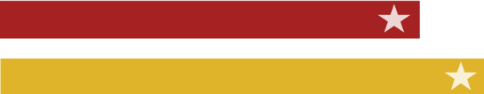

Every year, millions of Americans are unable to vote due to an outdated registration or a missed registration deadline. As many as 1 in 4 Americans are not registered, with that figure higher for youth and communities of color.

**National Voter Registration Day (nationalvoterregistrationday.org)** is an annual nonpartisan day of coordinated action in communities across the country, in the media, and online that raises awareness of registration opportunities, distributes critical voting information, and celebrates our country’s democracy. Nearly 4.7 million voters have registered to vote as part of the holiday since its founding in 2012, including 1.5 million [in 2020.](https://nationalvoterregistrationday.org/documents/2021/02/2020-national-voter-registration-day-final-report-digital.pdf/)

Over the last decade, the holiday’s success has been a result of the collective efforts of thousands of partners at the national and local levels, including high schools, colleges and universities, nonprofits, libraries, businesses, digital platforms, media partners, and more.

**Partner Benefits**

**National Voter Registration Day partners** represent organizations of all sizes and types, and are in all fifty states plus D.C. Since 2018, more than 4,000 community partners have joined in the National Voter Registration Day effort each year by organizing in-person voter registration events or spreading the word online on the holiday. Every year, about 30% of holiday partners are completely new to voter registration!

**Partners celebrate** **the holiday in a range of ways,** including: organizing in-person voter registration drives in public places, holding internal events to register employees, sending emails to their email contacts or communities sharing registration information and links, and more. Partners agree to remain nonpartisan in their participation in the holiday and to make their events a celebration of our shared democracy!

**National Voter Registration Day is endorsed by all major election official associations**, including the National Association of Secretaries of State (NASS), the National Association of State Election Directors (NASED), the U.S. Election Assistance Commission (EAC), and the National Association of Election Officials.

**As a 2022 Partner, you will receive:**

* **Free swag:** All partners receive a custom shipment of National Voter Registration Day-branded posters and stickers to give events a unified and celebratory feel! Posters and stickers are available in English, Spanish, and multiple additional languages.
* **Communications support:** Partners receive a Communications Strategy Guide and calendar, sample social media copy and shareable graphics, suggested nonpartisan message guidance and talking points, and more.
* **Access to live training webinars:** Every year, we host a series of webinars featuring voter engagement experts and on-the-ground partners to share all of the best practices, tips, and tricks needed to make your event a success.
* **Up-to-date resources specific to your state and community:** Voter registration drive rules differ by state (as does voting in general!), and can be confusing as a result. We’ve got your back with all of the state-specific resources and information you need no matter where you live.
* **Public recognition in National Voter Registration Day communications:** Our partners are the key to our success, and uplifting your hard work and impact is one of our top priorities! All partners are listed publicly on our website and receive regular shout-outs on social media, our podcast, and other communications.

**Ready to be part of a nationwide effort to help get America #VoteReady on September 20, 2022?**

**If the answer is YES, sign up** HERE

